Created a personalized database in MongoDB- answered specific assignment questions pertaining to query-by-code functions, references, directives and ad-hoc queries such as Perl-compatible regular expressions and range operators. Worked with returning deeply nested subdocuments.

Q1.



Q2. 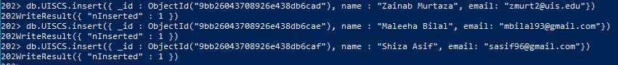





Q3.

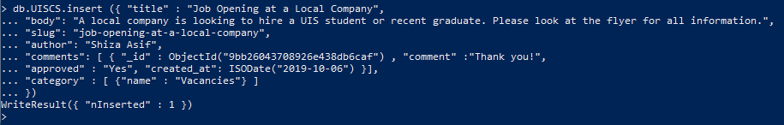

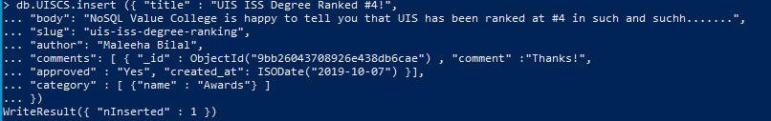

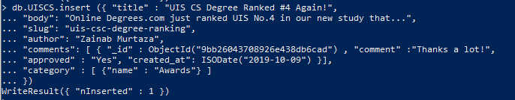



Q4.

